REASIS User Manuel

Interface Introduction
This section details the user interface and functions of the REASIS application. The application consists of four basic tabs that provide access to engine parameter determination, numeric results, visualization of the result and unit conversions: Parameters, Parametric Conclusion, Graphs, Unit Conversion.

1. Parameters Tab
The “Parameters” tab is designed as the main control panel where the user can adjust engine parameters. The engine type and other basic parameters are selected on this tab.
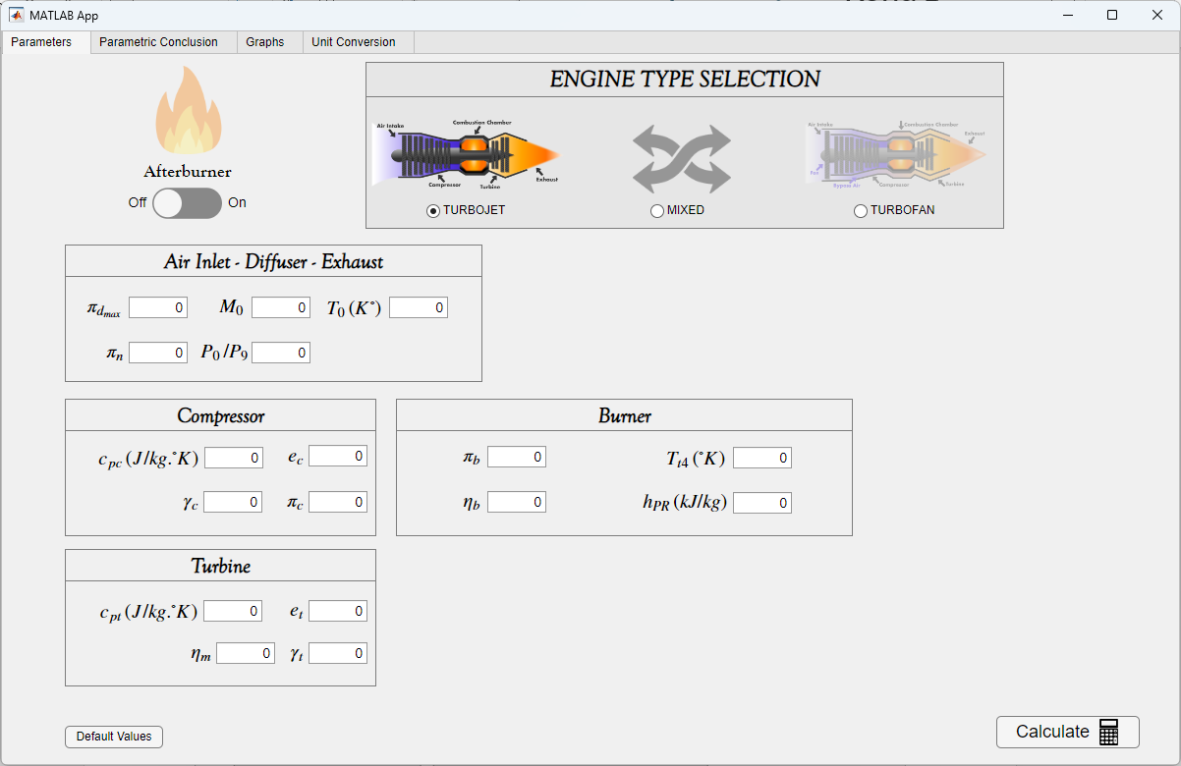
Engine Type Selection: The user should select one of the Turbojet, Turbofan (separated), and Mixed Turbofan options to determine the engine type that suits their needs. This selection triggers certain calculation modules of the application and ensures that the appropriate algorithms work.
Afterburner Status: After determining the engine type, the user specifies whether there will be an operation in the afterburner region by selecting one of the "Afterburner On" or "Afterburner Off" options.
Parameter Entry: After the afterburner status and engine type selection, many separate sections are opened for the user to enter the relevant values of the engine components. Each section contains separate fields for the entry of parameters related to the relevant component of the engine. Additionally, the "Default Values" button at the bottom left adjusts the inputs to the "Mixed Turbofan Engine with Afterburner On" example. When the user wants to learn the meaning of any indicator or performance criterion, they can display the explanation of what this value means by placing the pointer bar on the relevant value.
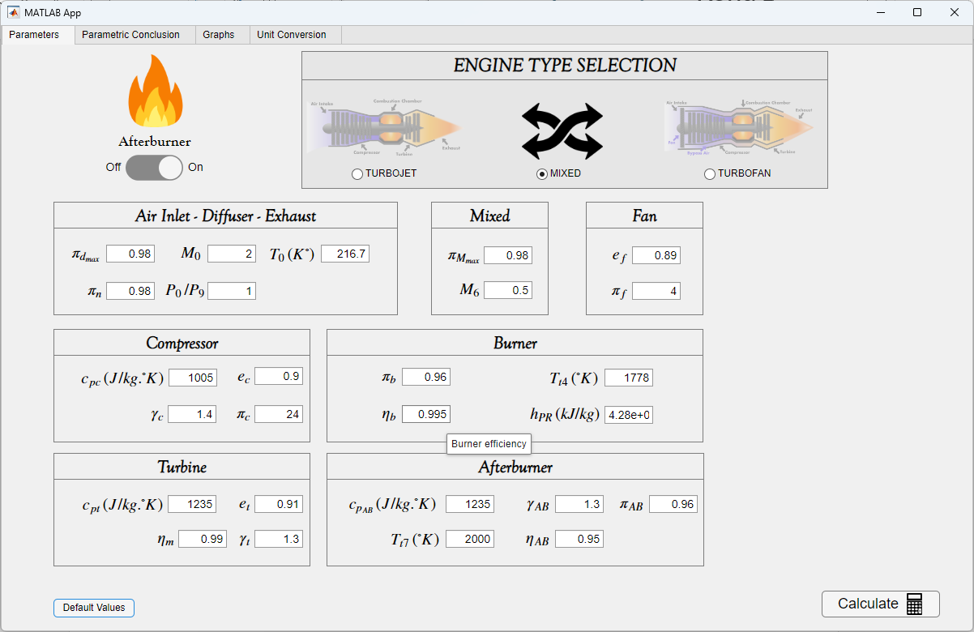

Calculate Button: After all necessary selections and parameter entries are made, the Calculate button in the lower right corner is clicked to automatically switch to the “Parametric Conclusion” tab. This process starts with the calculations according to the values entered by the user and allows the results to be viewed. It may take some time to calculate and move to the next tab.

2. Parametric Conclusion Tab
This tab displays the numerical results obtained from parametric cycle analysis. All thermodynamic ratios, efficiency values, temperature and pressure ratios, fuel–air ratios, Mach numbers, and performance indicators are presented in this section.
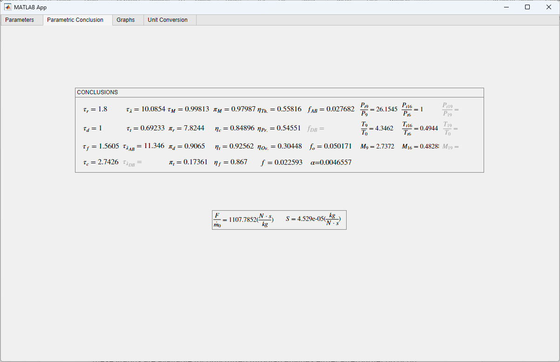

3. Graphs Tab
After completing the parametric cycle calculation, the user can proceed to the “Graphs” tab to visualize how engine performance parameters vary with selected input variables. In this section, graphical representations of key performance indicators are generated based on the calculated cycle results.
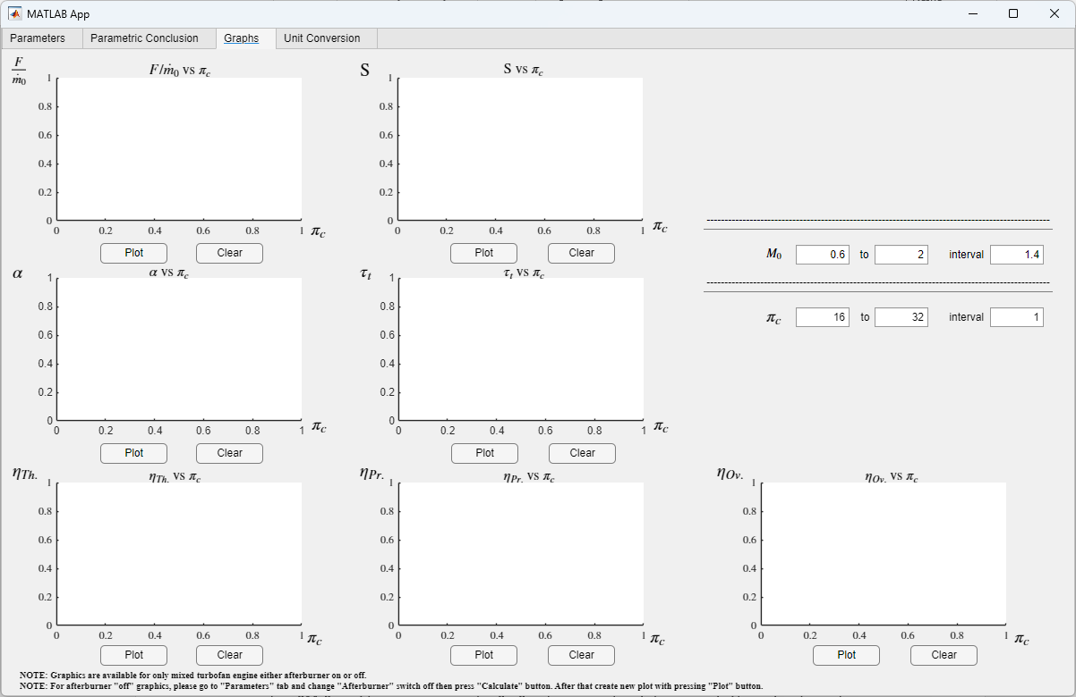

Graphic and Table Display: The graphs allow the user to visualize the results in line with the engine parameters they select. As stated in the note below, these graphs are available for only mixed turbofan engines either afterburner on or off.

Value Adjustments: In the upper right corner, the ranges and increments of the Mach number “M₀“ and compressor pressure ratio “π_{c}“ values can be determined. The adjustments made in these fields do not affect the "Parametric Conclusion" tab. These editing fields only cause changes in the graphics.

Graph Drawing: After the user completes all parameter adjustments, click the Plot button at the bottom of the graphs (It may take some time to plot the graph). Each curve's meaning in the graphs is indicated with the relevant legend (title). Additionally, when the pointer is paused on a certain point in the graphs, the calculated values for that point are displayed.
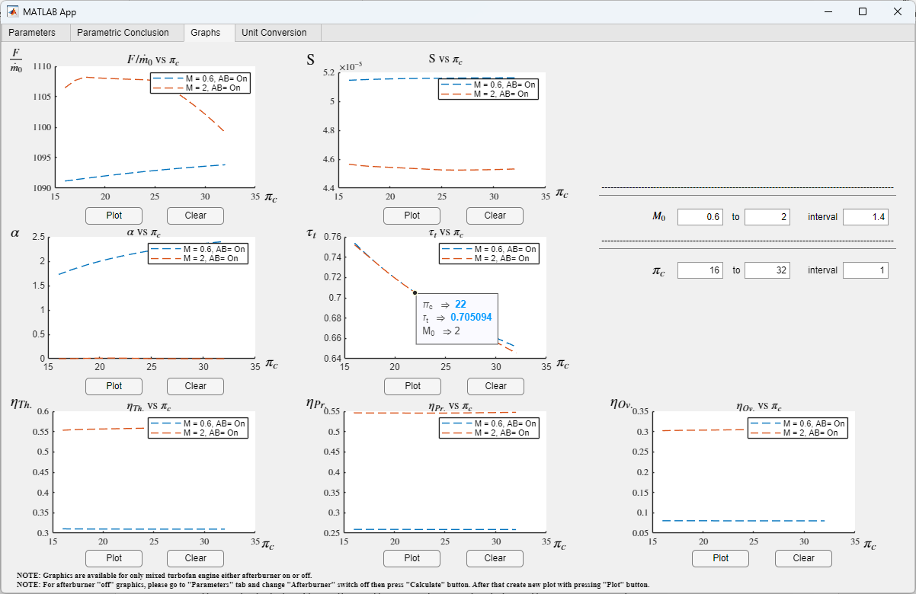
Clear Button: By clicking the “Clear” button, the current graph is cleared, returning to the initial state. This allows the user to recalculate with new parameters.

Afterburner Comparison: When the user returns to the “Parameters” tab, selects the "Afterburner Off" option, and clicks the "Calculate" button again, new conclusions are added. Then, if the user clicks the "Plot" button, new graphs will be added to the previous one. With this way, Afterburner “On” and Afterburner “Off” results can be compared on the same graph, allowing the user to compare different scenarios based on the same values.
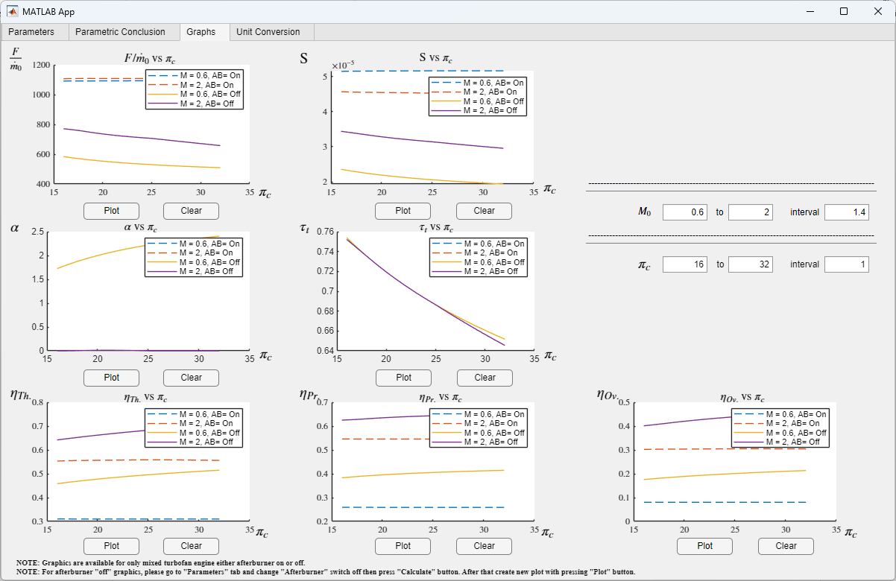

4. Unit Conversion Tab
The “Unit Conversion” tab is where the application allows the user to switch between SI units and Imperial units.
